EYFS
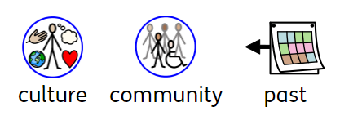
YEAR 1
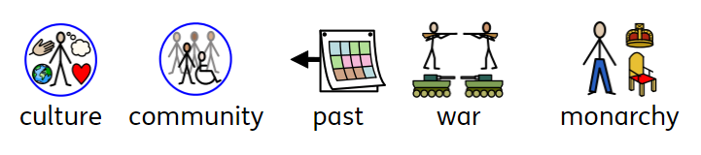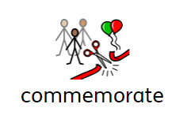
YEAR 2
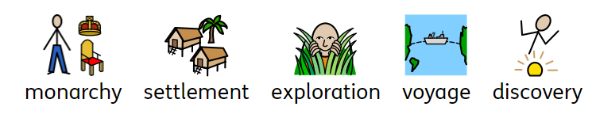

YEAR 3
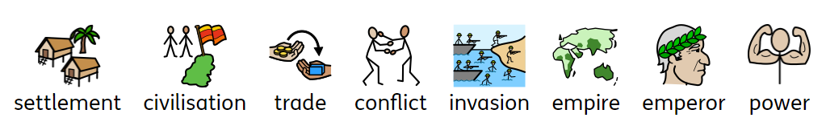

YEAR 4
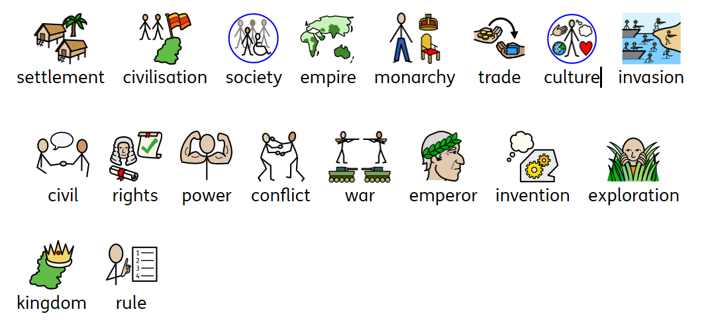

YEAR 5
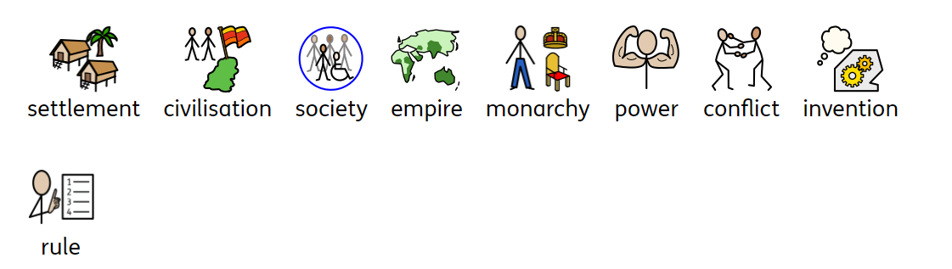
YEAR 6


